**TRAINING PRACTIVE – WEB APPLICATION**

**Time: 2-3 Weeks(Full time)**

**Intern:**

**Content**

**Build a simple photos Website:**

**Requirement:**

* Technical:
  + PHP / NodeJS + ExpressJS
  + MySQL
  + jQuery
  + Do not use other libraries/packages
* Our system has 2 main module: Admin & User. With 5 screens: (ex. Our domain is image.savvycom.vn):
  + Admin - Login: image.savvycom.vn/admin/login
  + Admin - Albums list: image.savvycom.vn/admin
  + Admin - Album detail: image.savvycom.vn/admin/{album-alias}
  + User - Homepage / Albums list: image.savvycom.vn
  + User – Album detail: image.savvycom.vn/{album-alias}
* Our system must avoid most popular security risks:
  + SQL Injection
  + Cross-Site Scripting (XSS)
  + Broken Authentication and Session Management
  + Insecure Direct Object References
  + Cross-Site Request Forgery (CSRF)
* Nice User interface (Example photos are only mockup)
* Support responsive design: Tablet 768px, Mobile 425px
* Nice Coding convention

**Screens Description**

1. **Admin - Login**

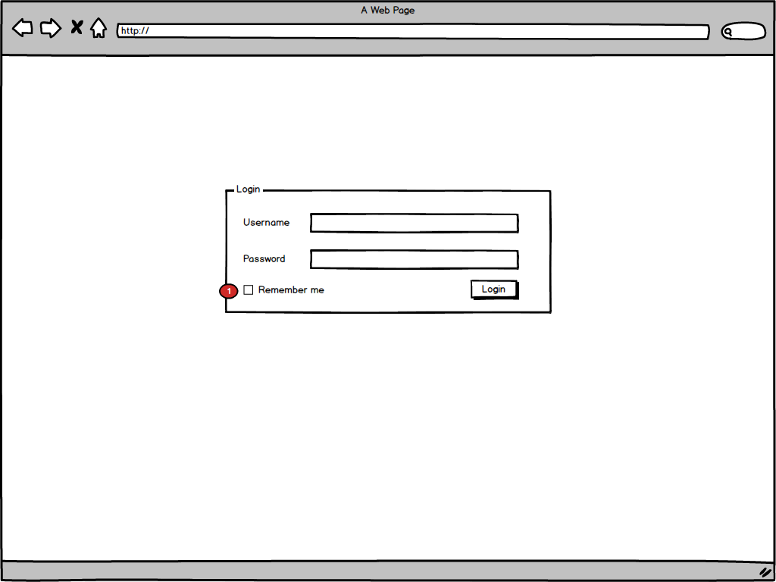

**Requirement:**

* + Admin account is pre-create in database. There is no signup functionality.
  + When enter any Admin page, redirect to this page if not logged in.
  + Note:
    1. Remember me: When checked, keep user logged in even if he close the browser and reopen it.

1. **Admin – Albums List**

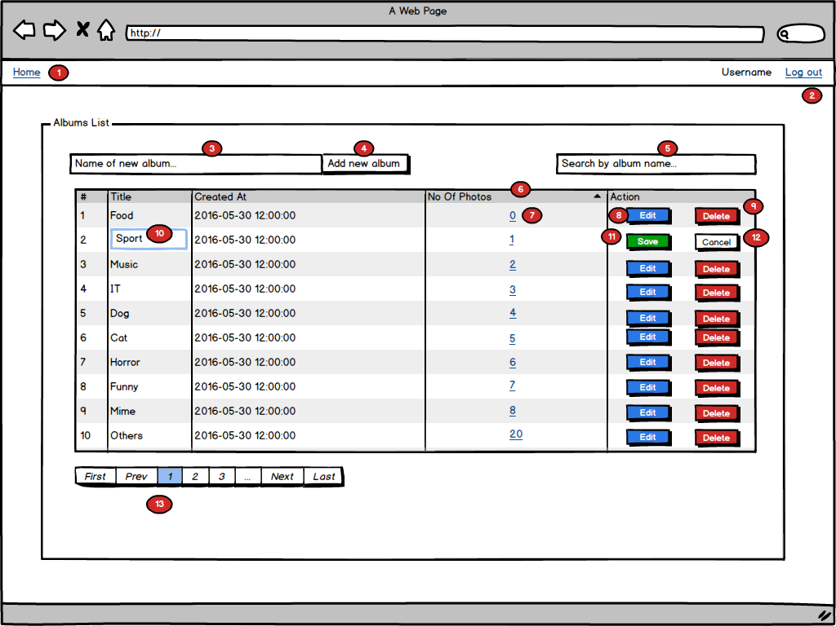

**Requirement:**

* + List all albums. Support: Searching, Sorting, Pagination
  + Album has an alias, built from it’s name. This is for more beautiful url. Ex. Album “Hello World” -> alias “hello-world”
  + Note:
    1. Link to Admin Homepage (Albums List).
    2. Logout: Logout and redirect to Admin Login
    3. New album title input.
    4. Add new album button: Submit new album when click. Album name must be unique. After submit, redirect back to Albums List + show notification(success or error).
    5. Search input: Use to search album by name. Search when press enter key.
    6. Table heading: Click to sort that column. Table can be sort by: Title, Created At, No of Photos. Default sort by No Of Photos.
    7. No of photos: Click to view list photos of album.
    8. Edit button: Click to enter “edit mode” of that album.
    9. Delete button: Delete an album and all photos of that album. Confirm before delete.
    10. Album title button: For “edit mode”
    11. Save button: For “edit mode”. Click to save album changes.
    12. Cancel button: For “edit mode”. Click to cancel changes and return to normal mode.
    13. Pagination: Limit 10 albums per page. Do not show if there is only 1 page or less.

1. **Admin - Album Detail**

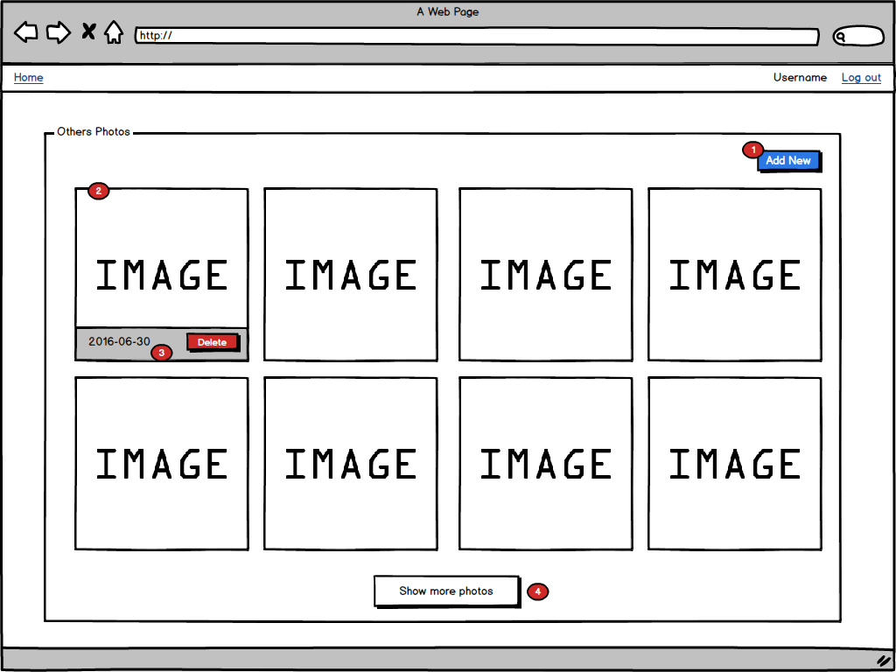

**Requirement:**

* + List all photos of an album
  + Note:
    1. Add New Button: Click to select new photo to upload by using Ajax. Disable button when uploading. Photo must be: jpeg/png, <= 5MB.
    2. Photo: Click to view larger. See “004.Admin - Album Photos 2.png”.
    3. Photo info: Show when hover on photo. Include Created Date and Delete button. Confirm before delete.
    4. Show more photos: Click to load more photos by using Ajax. Do not show if there is no more. Limit 8 albums per page.

1. **User - Homepage**

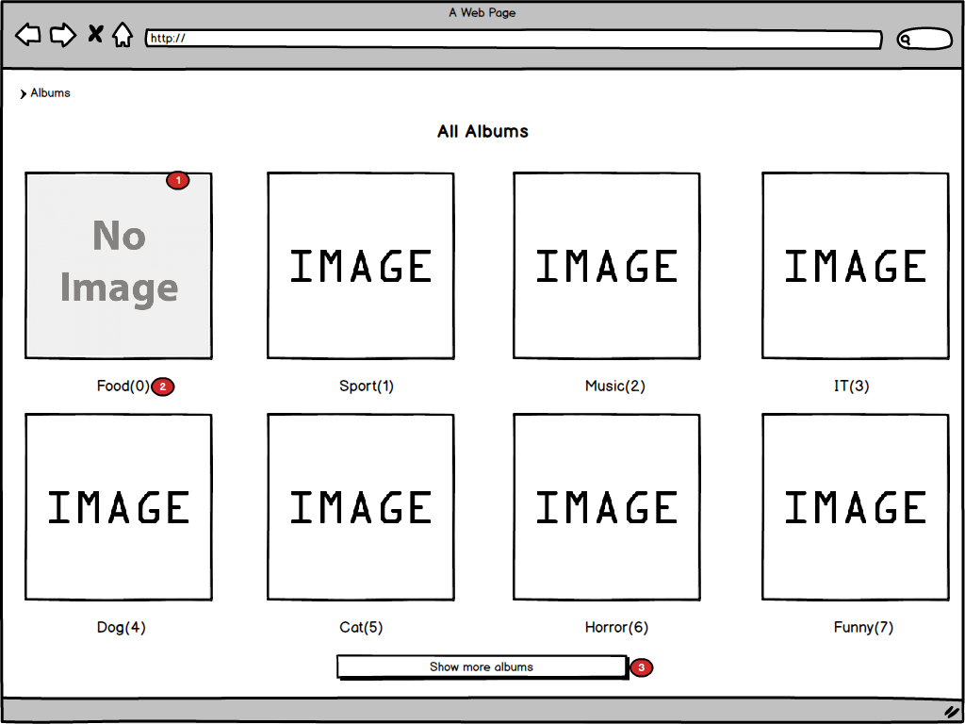

**Requirement:**

* + List all albums.
  + Note:
    1. Album block: Has a thumbnail. If album has no photos, use a default “No image”, else use random photo of album. Click to go to album detail
    2. Album title and number of photos
    3. Show more albums: Click to load more albums by using Ajax. Do not show if there is no more. Limit 8 albums per page.

1. **User - Homepage**

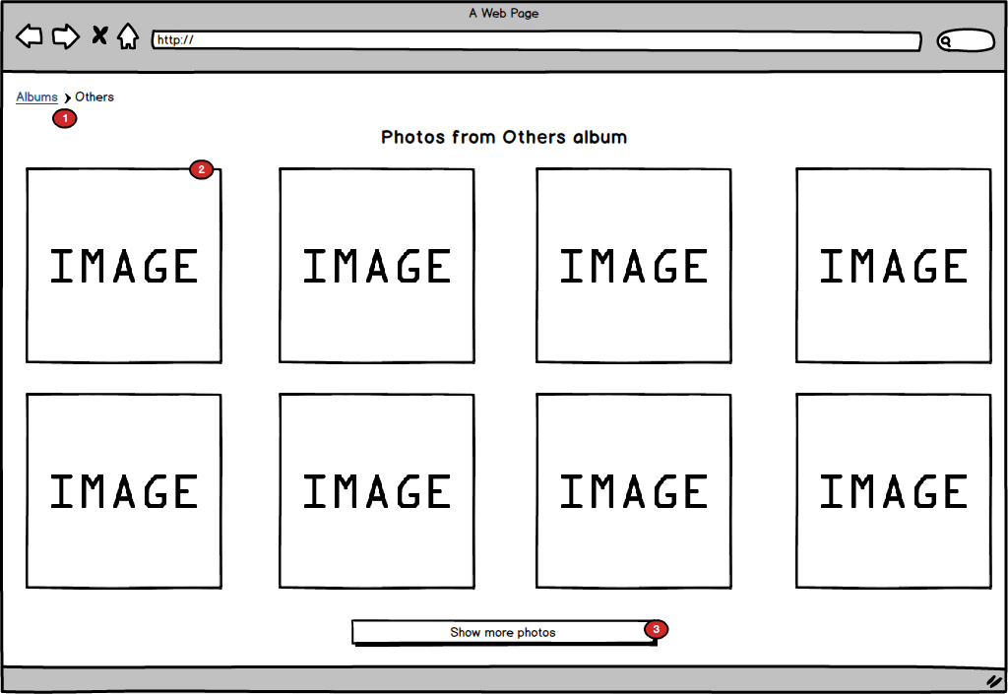

**Requirement:**

* + List all photos of an album.
  + Note:
    1. Breadcrumb
    2. Image: The same as in Admin but no Delete button.
    3. Show more albums: Click to load more albums by using Ajax. Do not show if there is no more. Limit 8 albums per page.